# OPM Everest Egg optimization

# Case preparation

**Steps:**

1. Downloaded fresh Egg model.
2. First run in Eclipse to see if Eclipse replicates benchmark results [*2]. Then tested OPM. Eclipse and OPM results in line with benchmark [*2].

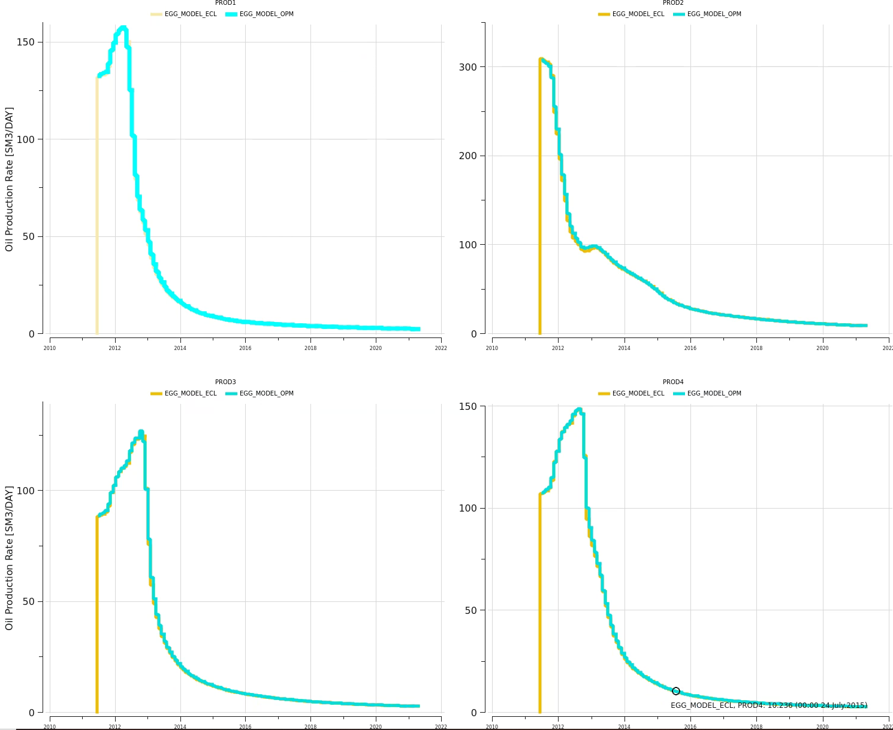

Figure 1: Comparison of Eclipse and OPM Egg case

**Conclusion:**

Replication of [*2] works if permeability input file *mDarcy.INC* is used. [*2] does not use/plot the ensemble results, instead benchmark uses a single realization with *mDarcy.INC* as permeability input.

# Modifications to DATA file for Everest simulation

**STEPS**

Following changes were implemented:

* Removed *mDarcy.INC* by realization depending permeability path
* Removed RPTONLY
* Added RPTRST with 'BASIC=4' 'FREQ=2' 'ALLPROPS'
* Added FOIP, FPR to SUMMARY
* Changed START to 24.03.2025
* Removed TUNNING
* Renamed *realization 100* to *realization 0* to be consistent with Eclipse default input format.

# References

[*1] <https://data.4tu.nl/articles/dataset/The_Egg_Model_-_data_files/12707642>

[*2] https://rmets.onlinelibrary.wiley.com/doi/epdf/10.1002/gdj3.21